1. Vocabulary List

to put on sth. | etw. anziehen
to wear | tragen
to dye | färben
to suit sb. | jdm. passen, gut stehen
cloth | Stoff
to manufacture | herstellen
appearance | Erscheinung
Physical appearance
attractive | attraktiv
chubby | mollig
gorgeous | wunderschön
obese | übergewichtig
scruffy | ungepflegt
flabby | schlapp
bald | glatzköpfig
ugly | hässlich
well-built | gut gebaut
slim | schlank
well-dressed | gut gekleidet
Cosmetic surgery
surgery | Operation
surgeon | Chirurg
to mold | formen
to get sb. hooked on sth. | jdn. mit etw. anfixen
flawless | makellos
skin graft | Hauttransplantation
to implant sth. | etw. einsetzen
vanity | Eitelkeit
to tighten | straffen
wrinkle | Falte
to scale sth. | etw. vergrößern
Beauty contests
beauty pageant | Schönheitswettbewerb
participant | Teilnehmer
to present oneself | sich präsentieren
to assess | bewerten
Tattoo and piercing
ink | Tinte
needle | Nadel
tattooist | Tätowiere
to pierce | stechen

2. Pictures

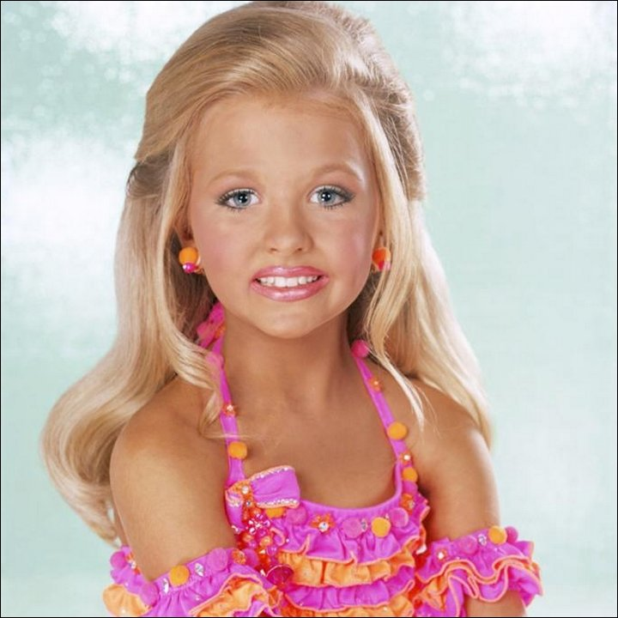

Sources:
http://funguerilla.com/images/strange-weird/child-beauty-pageants/child-beauty-pageants04.jpg
http://cac-nh.org/wp-content/themes/cac/images/smile.png

3. Text
What is True Beauty?

There are a thousand definitions of beauty. And there are many degrees of each. Beauty is in the eye of the beholder. There is sadness in beauty. Beauty can be ugly. It is a concept that has haunted poets, artists and academics for centuries.
Males are visual creatures. In their minds' eye, like the posters teenage boys hang on their bedroom walls, men have an inflated idea of beauty. But to see how he really finds beauty in his surroundings, look at the girl with whom he spends time and feels most comfortable. She is often the opposite of the bedroom poster, maybe a friends, sister, aunt or cousin. She is the one he enjoys being with most. To be able to laugh with someone, we must drop our guards. Beauty is to be free and to act naturally. Oddly, getting there can be difficult.
Today, messages and information are aimed at us in very new ways. It is happening faster than humans can adapt and evolve. Life is demanding more than we can give. In turn, you rely on text messages rather than physical conversation. The heart is missing in our lives and you must bring it back.
We judge the book by its cover. It's usually untrue and unwise, but we place a great weight of importance on the first impression. In truth, a first impression offers fast, mostly visual cues, to make an assumption of another. Physical appearance is the first thing we see and it becomes our Achilles heel. The first impression is always the most expensive.
It is expensive because of what we lose. The priority one sets on appearances in the physical realm is to deny oneself the quality and beauty of the spirit. If you choose to focus on the beauty within, you will receive the value of true communication with another. To ignore the essence of another is to deny your own humanity.
Beauty has always been costly. By the time you have been plucked, pinched and enhanced, you can easily spend a fortune on the latest product or the most popular nip and tuck. The pursuit of beauty can also deny nature. In the fevered race to erase a wrinkle, we try to stop time and the slow and inevitable progress of nature. It is a fight no human can win. Beauty can also be a sport or a goal. Can you be more beautiful than you already are? No. Sure, every car needs a fresh coat of paint and a few new pin stripes but the real, true beauty comes from within your chassis.
There is boldness in choice and people can easily recognize it in you. To choose beauty, determines that you have pondered the question, objectified the issues and made a choice. You have asked, "What will I project today? What will I put out into the world?" Then you choose and follow it through. Embracing victimhood is a way to lick your past wounds but it never yields any positive future-oriented gains. You lead by example. Choose beauty.
Look at a flower as you would look upon a work of art. Appreciate it. Enjoy it. Relax and just let it all in. Then look at yourself the same way. You are a perfect and unique creation of nature, just like a flower. This may be hard to do and you must persist through all of the negativity and voices in your head. Remember those voices do not speak truth. They are merely the echoes of insecurity and comic relief. Appreciation for beauty isn't forced. Beauty cannot be beaten into you. Beauty must be invited and it must flow. If you want to exhibit your true nature, all you can do is let go.
It is hard to let go. These days, with Life howling around us like a hurricane, we instinctively try to hang on for dear life. To be beautiful, to live in the flow, is a monumentally important task that requires only openness, desire and a few simple actions.
Silence is the key that unlocks the mystery. A quiet meditation. Say a prayer. Sit down and have a little chat with yourself. Open this door and you will be answered with your own beauty.
Do something that makes you happy. Let go and take the time for yourself. Something simple. Call a friend. Go to a movie. Get a massage. You do not need to spend a hundred dollars. Shop, but don't buy anything, at a flower shop. Bake a cake. Take a hike. Do something that is purposed for you. When this happens, your beauty will begin to show. Others will recognize it and be drawn to it. You have allowed your beauty to flow.

4. Questions

- Do you agree with the quote “Beauty is in the eye of the beholder”?
- How far can change tattoos and piercings a person’s physical appearance?
- Do you think child beauty pageants degrade young girls? Should they be banned?
- Consider a brand that you prefer for a certain food, clothing, or other product. What made you choose that brand over others, and how would you describe that brand to someone considering it?

Source:
http://www.keen.com/articles/love/what-is-true-beauty

