Films

"Life is like a box of chocolates - you never know what you're gonna get."
― Forrest Gump

1) How can films affect us?
2) Would you rather read a book or watch a movie? Why?
3) If you could be in a movie which one would it be?
4) What do you think is the film in the first picture about?

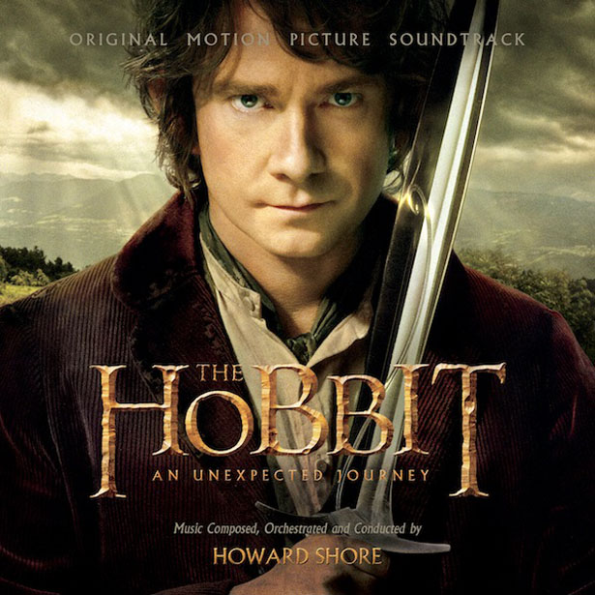
https://www.google.at/search?q=dvd+cover&espv=2&biw=1366&bih=667&source=lnms&tbm=isch&sa=X&ei=3XO1VLvIH4LoOJGBgegK&ved=0CAYQ_AUoAQ#tbm=isch&q=Der+Hobbit+dvd+cover&imgdii=_&imgrc=hsjdsSko8d6CjM%253A%3BlY_O1GTGpDiapM%3Bhttp%253A%252F%252Fwww.dvd-forum.at%252Fimg%252Fuploaded%252F23800_603420ec12e0ce8077f64ed537776967_1.jpg%3Bhttp%253A%252F%252Fwww.dvd-forum.at%252Fnews-details%252F32806-dvd-blu-ray-der-hobbit-v-termin-bekannt-neue-cover%3B701%3B993

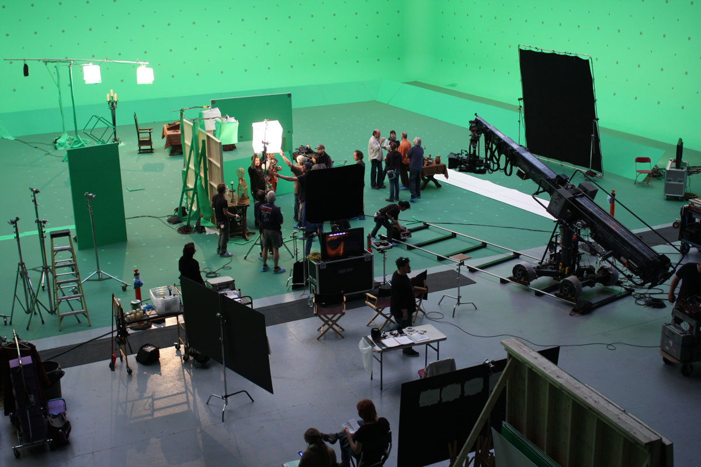
https://www.google.at/search?q=forrest+gump+englisches+zitat&biw=1366&bih=667&espv=2&source=lnms&tbm=isch&sa=X&ei=XIi1VIiCO8XbPcqugJgJ&ved=0CAYQ_AUoAQ&dpr=1#tbm=isch&q=Film+set&imgdii=_&imgrc=I-fCgP9c0KzPlM%253A%3BDDT8OP7ybrVhSM%3Bhttp%253A%252F%252Fstudents.purchase.edu%252Fterence.gardner%252Fhow_to%252Fhow_to%252Fimages%252FACSFS_O_001_Film-Set1.jpg%3Bhttp%253A%252F%252Fwww.starside.com%252Fservices%252Fsecurity%252Fcelebrity-bodyguard-and-film-set-security%252F%3B1200%3B800
Regisseur | Director/producer
Rückblende | Flashback
Schneiden | Editing
Fortsetzung | Sequel
Drehbuch | Screenplay
Vor-/Nachspann | Credits
Standbild | Freeze-Frame
Aufblende | Fade-in
Vogelperspektive | Aerial shot

Actor, costume, special effects, genre, supporting role, oscar, sound editing, sound mixing, costume design, animation,

